SYSTEMS DIVISION

IPD OCC
TEST PLAN DOCUMENT
WR # 2111

DRAFT

Prepared By:
Back Office IPD Team

1. OCC file and report creation test 4
1.1. occ file and report creation test 4
1.1.1. Test Description: 4
1.1.2. Test Environment 4
1.1.3. Expected Results 4
1.1.4. Actual Results 4
2. OCC sc0131 report generation TEST 6
2.1. OCC sc0131 report generation Test 6
2.1.1. Test Description: 6
2.1.2. Test Environment 6
2.1.3. Expected Results 6
2.1.4. Actual Results 6

OCC FILE AND REPORT CREATION Test

OCC File and Report Creation Test

Test Description:
The OCC files to be reconciled reside on the MVS system on tape. They should be copied to DASD for the verification. The DSNs are CBOE.OCC.AS.ADDRECS(n) and CBOE.OCC.AS.ADDRECS(n –1) where n is the generation for the after split process and n –1 is the generation for the before split process for the trading day to be verified. The tester will need an MVS logon to do this. Infopac is used to verify the as0800 reports. Infopac may be gotten to by http://infopacnt on the browser or INFO using Mocha or some other mainframe login software.
The pre-adjustment verification is as follows:
The following script will be used to create the OCC series file and report file: createOccFileBeforeAdj. The series file FTPd to MVS is RJE.UNIX.IPD.OCC.SERIES.BEFORE.ADJ. The series report file FTPd to MVS is RJE.UNIX.IPD.OCC.SERIES.BEFORE.ADJ.REPORT. This script will be run for a particular next trading day. If the next trading day desired is not the one on the table bus_day an extra program parameter can be added at the end of the execution line in the form DD-MM-YYYY (i.e. 23-08-2005) so that the proper day can be processed and the results compared against the production copies and infopac reports for that day. This reconciliation is verified the Daily excel spreadsheet against CBOE.OCC.AS.ADDRECS(n –1: usually –1) and the corresponding report on Infopac.
The post-adjustment verification is as follows:
The following script will be used to create the OCC series file and report file: createOccFileAfterAdj. The series file FTPd to MVS is RJE.UNIX.IPD.OCC.SERIES.AFTER.ADJ. The series report file FTPd to MVS is RJE.UNIX.IPD.OCC.SERIES.AFTER.ADJ.REPORT. This script will be run for a particular next trading day. If the next trading day desired is not the one on the table bus_day an extra program parameter can be added at the end of the execution line in the form DD-MM-YYYY (i.e. 23-08-2005) so that the proper day can be processed and the results compared against the production copies and infopac reports for that day. This reconciliation is verified the Daily excel spreadsheet against CBOE.OCC.AS.ADDRECS(n: usually 0 ) and the corresponding report on Infopac.

Test Environment
IPD and ipdsd000 and MVS.

Expected Results
- Compare RJE.UNIX.IPD.OCC.SERIES.BEFORE.ADJ with CBOE.OCC.AS.ADDRECS(n –1). There should be no differences.
- Compare RJE.UNIX.IPD.OCC.SERIES.BEFORE.ADJ.REPORT with the appropriate as0800 report on infopac. There should be no differences. RJE.UNIX.IPD.OCC.SERIES.BEFORE.ADJ.REPORT is a report format of RJE.UNIX.IPD.OCC.SERIES.BEFORE.ADJ.
- Compare RJE.UNIX.IPD.OCC.SERIES.AFTER.ADJ with CBOE.OCC.AS.ADDRECS(n ). There should be no differences.
- Compare RJE.UNIX.IPD.OCC.SERIES.AFTER.ADJ.REPORT with the appropriate as0800 report on infopac. There should be no differences. RJE.UNIX.IPD.OCC.SERIES.AFTER.ADJ.REPORT is a report format of RJE.UNIX.IPD.OCC.SERIES.AFTER.ADJ.

Actual Results
The data in the MVS files and infopac reports.

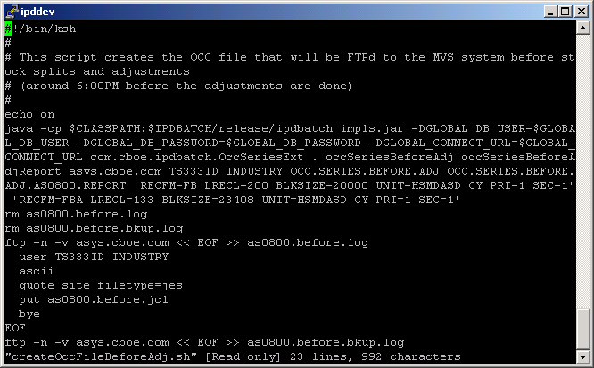
This is the unix script createOccFileBeforeAdj.sh before adjustments. The default next trading day is obtained from the table bus_day. If another trading day is needed it can be added to the end of the execution line in DD-MM-YYYY format, for example 23-08-2005. This script will create the unix files occSeriesBeforeAdj and occSeriesBeforeAdjReport that will be FTPd to MVS with the names TS333ID.SERIES.BEFORE.ADJ and TS333ID.SERIES.BEFORE.ADJ.AS0800.REPORT. A similar test can be done for createOccFileAfterAdj.sh after adjustments.

OCC sc0131 report generation

OCC sc0131 report generation

Test Description:
This test will verify the MVS file created by the occCreateReport.sh script against the infopac report sc0131.

Test Environment
IPD and ipdsd000 and MVS. Test after the first test is complete

Expected Results
- Compare RJE.UNIX.IPD.OCC.SERIES.SC0131.REPORT with the appropriate sc0131 report on infopac. The only differences should be manual changed made through the TPF screens. Check with the users to verify that these changes were actually made. These changes should parallel the OCC file changes.

Actual Results
The data in the MVS file and infopac report.

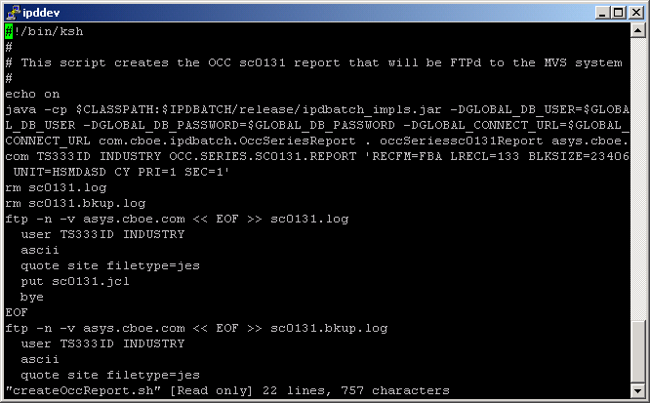

This is the unix script createOccReport.sh. The default next trading day is obtained from the table bus_day. If another trading day is needed it can be added to the end of the execution line in DD-MM-YYYY format, for example 23-08-2005. This script will create the unix file occSeriessc0131Report that will be FTPd to MVS with the name RJE.UNIX.IPD.OCC.SERIES.SC0131.REPORT.

